**CN LAB TEST**

**Objective:**

To setup two LAN and then connect them with two routers to form a WAN.

**Procedure:**

**Network Design:**

* Router1 connected to Router2.
* PC0, PC1, PC2, PC3, PC4 connected to Switch2 in Star topology.
* PC5, PC6, PC7, PC8, PC9 connected to Switch3 in Star topology.
* Switch2 connected to Router2
* Switch3 connected to Router3

**Step 1:**

1. Determine IP address scheme:

* Router2 to Router3 link
* Switch2 Network: 192.168.1.1/24
* Switch3 Network: 192.168.2.1/24

**Step 2: Configuring Router2**

1. Select the router and open CLI.
2. Press ENTER to start configuring Router1.
3. Activate privileged mode: Type enable
4. Access the configuration menu: Type config t (configure terminal)
5. Configure interfaces of Router1:

- Type interface FastEthernet0/0

- Configure with the IP address 192.168. 1.1 and Subnet mask 255.255.255.0

1. Serial 2/0/: (connected to Router2)

- Type interface Serial 0/0/0

- Configure with the IP address 192.168.2.1 and Subnet mask 255.255.255.0

1. Finish configuration:

-Type no shutdown to activate the interfaces

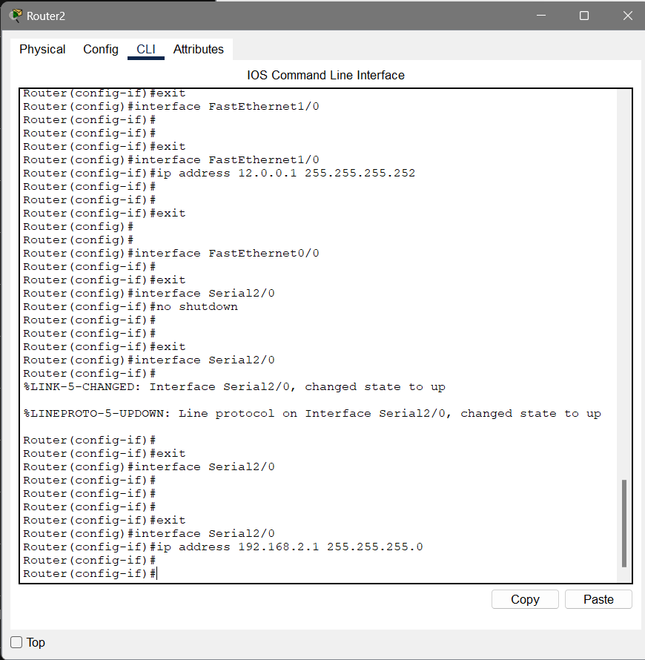

**Step 2: Configuring Router3**

1. Select the router and open CLI.
2. Press ENTER to start configuring Router1.
3. Activate privileged mode: Type enable
4. Access the configuration menu: Type config t (configure terminal)
5. Configure interfaces of Router1:

- Type interface FastEthernet0/0

- Configure with the IP address 192.168. 2.1 and Subnet mask 255.255.255.0

1. Serial 2/0/: (connected to Router2)

- Type interface Serial 0/0/0

- Configure with the IP address 192.168.1.1 and Subnet mask 255.255.255.0

1. Finish configuration:

-Type no shutdown to activate the interfaces

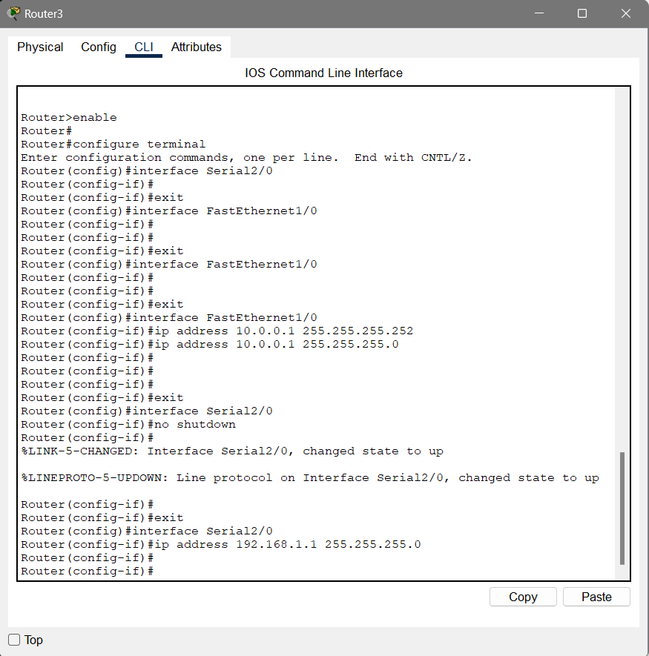

**Step 4: Configuring PCs**

1.Assign IP addresses to each PC in network Switch2:

○ PC0:

■ Go to the desktop, select IP Configuration, and assign the following:

■ IP address: 192.168.1.2

■ Subnet Mask: 255.255.255.0

■ Default Gateway: 192.168.1.1

……and so on(for all 5 PC)

2.Assign IP addresses to each PC in network Switch3:

○ PC5:

■ Go to the desktop, select IP Configuration, and assign the following:

■ IP address: 192.168.2.2

■ Subnet Mask: 255.255.255.0

■ Default Gateway: 192.168.2.1

……and so on(for all 5 PC)

**Step 7: Verify Connectivity**

1. Test the connectivity by pinging from PC0 to PC5:

○ Open the command prompt on PC0.

○ Type ping 192.168.2.2 and observe the response.

2. Test the connectivity by pinging from PC5 to PC0:

○ Open the command prompt on PC1.

○ Type ping 192.168.1.2 and observe the response.

**Step 8: Simulation**

1. Use the simulation mode in Cisco Packet Tracer.
2. Send a message from PC0 to PC5.
3. Observe the message being sent from the PC0 to PC5.
4. Then a confirmation message sent back to PC5 to PC0.

